==================================================

Running Genetic Algorithm with LightGBM...

==================================================

==================================================

=== GENETIC ALGORITHM OPTIMIZATION ===

==================================================

[Initialization]

- Population size: 30

- Generations: 20

- Crossover rate: 80%

- Mutation rate: 20%

- Search space: 16 feature

==================================================

=== OPTIMIZATION RESULTS ===

==================================================

▶ Best MSE achieved: 31079344.396795

▶ Time elapsed: 482.74 seconds

▶ Features selected: 15/16 (6.2% reduction)

▶ Selected features:

1. region

2. year

3. manufacturer

4. model

5. condition

6. cylinders

7. fuel

8. odometer

9. title_status

10. drive

11. type

12. paint_color

13. state

14. lat

15. long

▶ Convergence progress:

- Initial MSE: 37765430.8252

- Final MSE: 31079344.3968

- Improvement: 17.7%

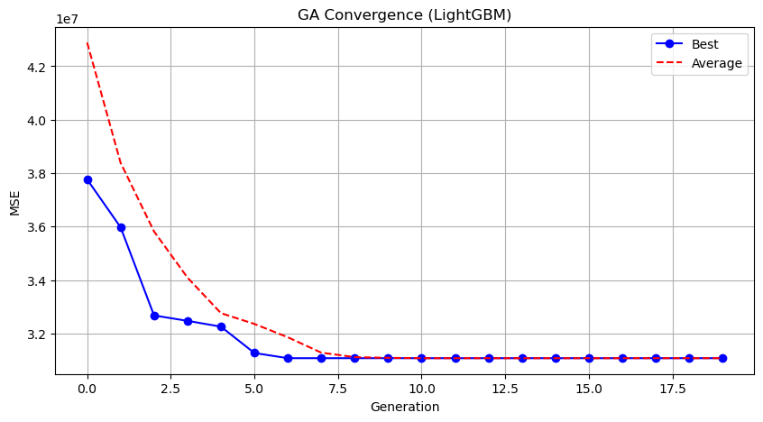

Genetic Algorithm completed successfully with MSE: 31079344.3968

==================================================

Running Particle Swarm Optimization with LightGBM...

==================================================

==================================================

=== PARTICLE SWARM OPTIMIZATION ===

==================================================

[Initialization]

- Swarm size: 30 particles

- Iterations: 20

- Cognitive weight: 0.5

- Social weight: 0.5

- Inertia weight: 0.5

- Search space: 16 features

- Target: Minimize MSE using LightGBM

==================================================

=== OPTIMIZATION RESULTS ===

==================================================

▶ Best MSE achieved: 31530543.654983

▶ Time elapsed: 496.05 seconds

▶ Features selected: 13/16 (18.8% reduction)

▶ Selected features (with weights):

1. region (weight: 0.726)

2. year (weight: 0.561)

3. manufacturer (weight: 0.820)

4. model (weight: 0.758)

5. condition (weight: 0.777)

6. cylinders (weight: 0.632)

7. fuel (weight: 0.705)

8. odometer (weight: 0.893)

9. drive (weight: 0.819)

10. type (weight: 0.751)

11. paint_color (weight: 0.562)

12. lat (weight: 0.514)

13. long (weight: 1.000)

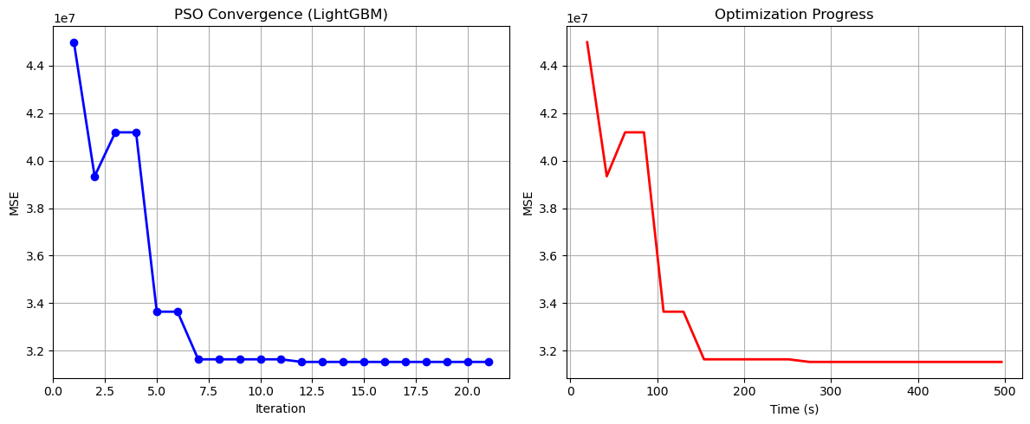

Particle Swarm Optimization completed successfully with MSE: 31530543.6550

==================================================

Running Whale Optimization with LightGBM...

==================================================

==================================================

=== WHALE OPTIMIZATION ALGORITHM ===

==================================================

[Initialization]

- Population: 30 whales

- Max iterations: 20

- Spiral coefficient (b): 1.0

- Search space: 16 features

- Target: Minimize MSE using LightGBM

==================================================

=== OPTIMIZATION RESULTS ===

==================================================

▶ Best MSE achieved: 31001711.492033

▶ Time elapsed: 491.78 seconds

▶ Features selected: 15/16 (6.2% reduction)

▶ Selected features:

1. region

2. year

3. manufacturer

4. model

5. condition

6. cylinders

7. fuel

8. odometer

9. title_status

10. transmission

11. drive

12. type

13. paint_color

14. lat

15. long

▶ Convergence progress:

- Initial MSE: 59006513.9510

- Final MSE: 31001711.4920

- Improvement: 47.5%

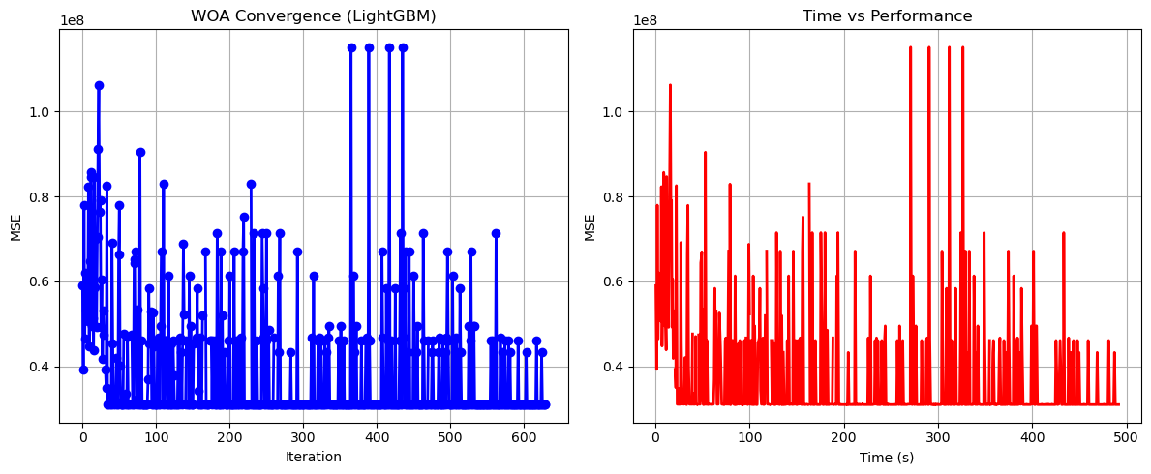

Whale Optimization completed successfully with MSE: 31001711.4920

==================================================

Running Squid Game Optimizer with LightGBM...

==================================================

==================================================

=== SQUID GAME OPTIMIZER (SGO) ===

==================================================

[Initialization]

- Players: 30 (15 offensive, 15 defensive)

- Max games: 20

- Search space: 16 features

- Target: Minimize MSE using LightGBM

==================================================

=== OPTIMIZATION RESULTS ===

==================================================

▶ Best MSE achieved: 31511215.057878

▶ Time elapsed: 427.15 seconds

▶ Features selected: 13/16 (18.8% reduction)

▶ Selected features:

1. year

2. manufacturer

3. model

4. condition

5. cylinders

6. fuel

7. odometer

8. title_status

9. transmission

10. type

11. paint_color

12. lat

13. long

▶ Convergence progress:

- Initial MSE: 32696609.4423

- Final MSE: 31511215.0579

- Improvement: 3.6%

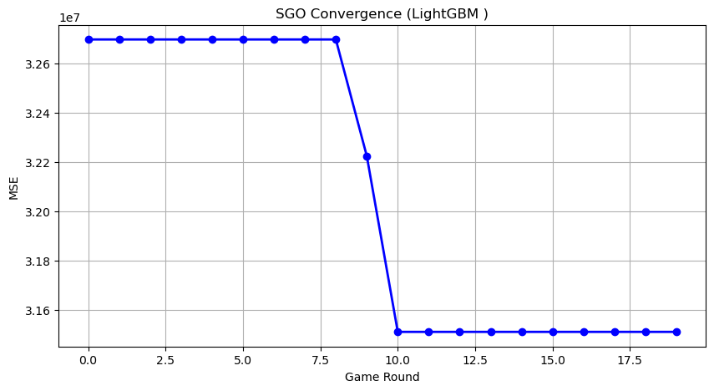

Squid Game Optimizer completed successfully with MSE: 31511215.0579

==================================================

Running PSH-Hyptrite with LightGBM...

==================================================

==================================================

=== PSH-HYPTRITE OPTIMIZATION ===

==================================================

[Initialization]

- Search points: 30

- Max iterations: 20

- Initial radius: 0.5 (adaptive)

- Hypersphere samples: 3 per point

- Search space: 16 features

- Target: Minimize MSE using LightGBM

[==================================================

=== OPTIMIZATION RESULTS ===

==================================================

▶ Best MSE achieved: 31079344.396795

▶ Time elapsed: 1461.59 seconds

▶ Features selected: 15/16 (6.2% reduction)

▶ Selected features (with weights):

1. region (weight: 0.794)

2. year (weight: 0.648)

3. manufacturer (weight: 0.522)

4. model (weight: 1.000)

5. condition (weight: 1.000)

6. cylinders (weight: 0.654)

7. fuel (weight: 0.761)

8. odometer (weight: 0.909)

9. title_status (weight: 0.633)

10. drive (weight: 0.613)

11. type (weight: 0.654)

12. paint_color (weight: 0.597)

13. state (weight: 0.585)

14. lat (weight: 0.710)

15. long (weight: 0.981)

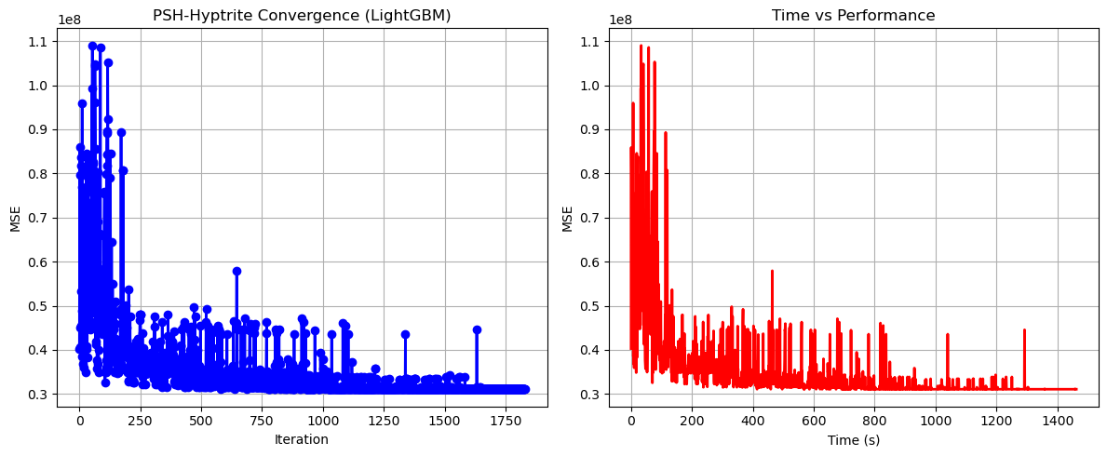

PSH-Hyptrite completed successfully with MSE: 31079344.3968

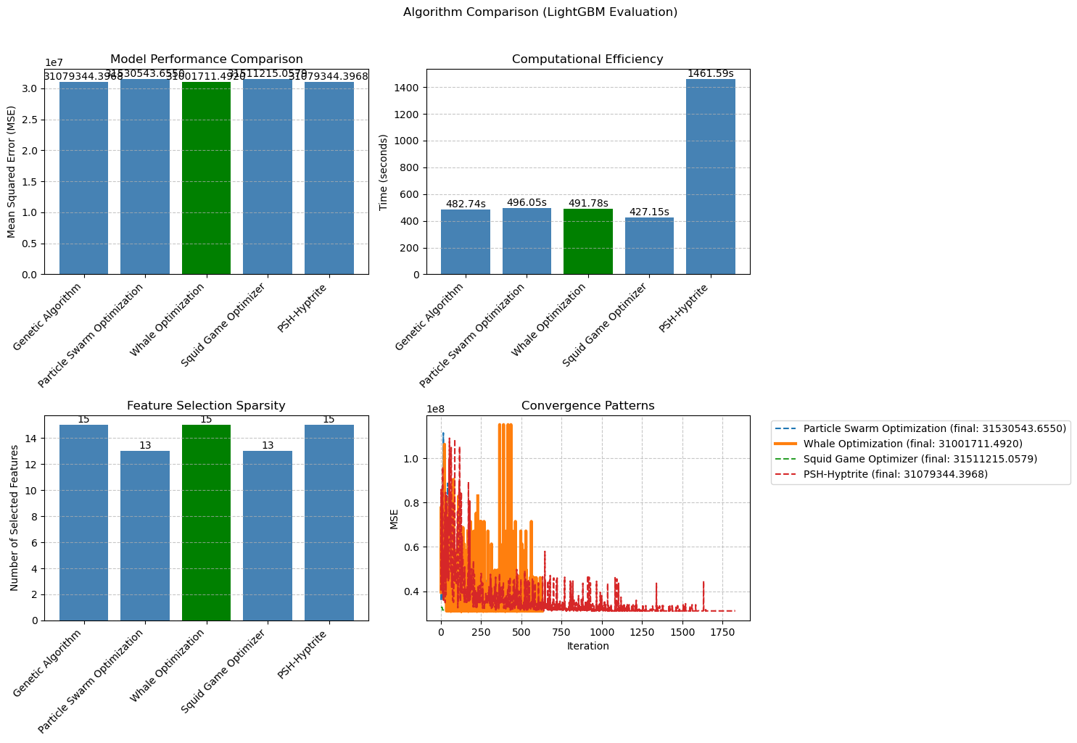

============================================================

=== FINAL FEATURE SELECTION RESULTS USING LightGBM ===

============================================================

🏆 BEST ALGORITHM: WHALE OPTIMIZATION

• MSE: 31001711.492033

• Time: 491.78 seconds

• Features: 15/16 (6.2% reduction)

📊 COMPARISON TABLE:

Algorithm MSE Time (s) Features

---------------------------------------------------------------------------

Whale Optimization 31001711.492033491.78 15

Genetic Algorithm 31079344.396795482.74 15

PSH-Hyptrite 31079344.3967951461.59 15

Squid Game Optimizer 31511215.057878427.15 13

Particle Swarm Optimization 31530543.654983496.05 13

🔍 SELECTED FEATURES:

1. region

2. year

3. manufacturer

4. model

5. condition

6. cylinders

7. fuel

8. odometer

9. title_status

10. transmission

11. drive

12. type

13. paint_color

14. lat

15. long

💡 Tip: Consider feature importance from LightGBM for further analysis